Project Report

Objective:
To analyze Indian medicine master data using PostgreSQL and SQL in order to identify manufacturer dominance, discontinued medicine risks, therapeutic substitution opportunities and pricing patterns.
The objective is to support pharmacy inventory planning, procurement optimization and alternative sourcing decisions through data-driven insights.

Table of content:
Table name med
Columns include:
- id (medicine id)
- name (medicine name)
- price (medicine price)
- is_discontinued
- manufacturer_name
- type(allopathic)
- pack_size_label
- short_composition1
- short_composition2
- medicine_type (tablet or capsules etc)

SQL Queries:

Q1. Identify top manufacturers controlling the majority of medicine listings to assess supplier dependency risk.
Query:
SELECT
manufacturer_name,
COUNT(name) total_product
FROM med
GROUP BY manufacturer_name
ORDER BY total_product DESC LIMIT 10;
Result:
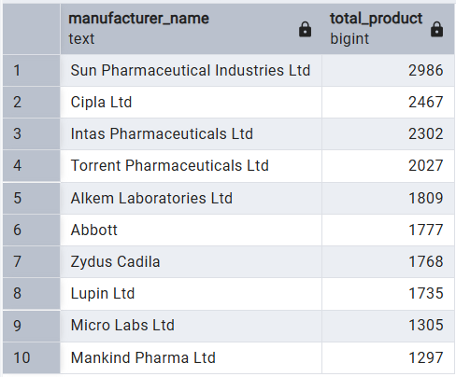

Q2. Analyze price ranges, average pricing per manufacturer and identify premium vs budget product segments.
Query:
WITH price_range AS(
SELECT
manufacturer_name,
MIN(price) AS lowest_price_med,
MAX(price) AS highest_price_med,
ROUND(AVG(price)::NUMERIC, 2) AS avg_cost_med
FROM med
GROUP BY manufacturer_name
)
SELECT
*,
ROUND(AVG(avg_cost_med) OVER() :: NUMERIC) AS overall_avg_cost,
CASE
WHEN avg_cost_med > ROUND(AVG(avg_cost_med) OVER() :: NUMERIC) THEN 'Premium'
ELSE 'Budget'
END AS cost_segment
FROM price_range
ORDER BY avg_cost_med DESC;
Result:
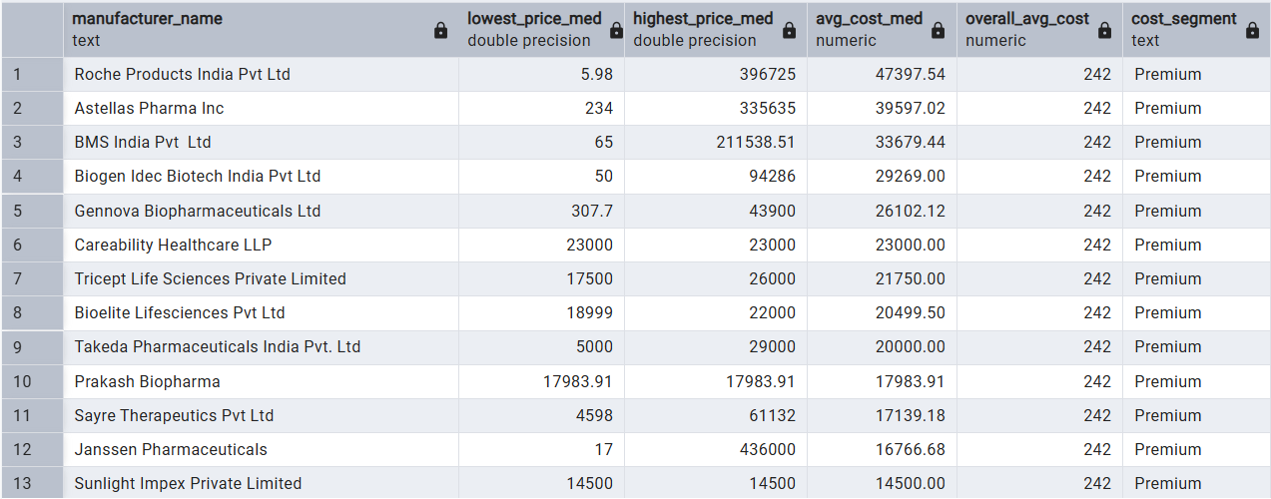

Q3. Measure the percentage of discontinued medicines and identify manufacturers or compositions with high discontinuation rates.
Query1:
SELECT
is_discontinued,
COUNT(*) AS total_count,
ROUND((COUNT(*) / SUM(COUNT(*)) OVER()),2) * 100 AS percentage_of_total
FROM med
GROUP BY is_discontinued;

Result1:
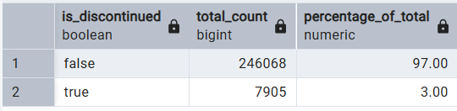
Qeury2:
SELECT
manufacturer_name,
COUNT (*) total_discontinued,
ROUND(COUNT (*) / SUM(COUNT(*)) OVER(),2) * 100 per_discontinued
FROM med WHERE is_discontinued = 'true'
GROUP BY manufacturer_name
ORDER BY total_discontinued DESC LIMIT 10 ;

Result2:
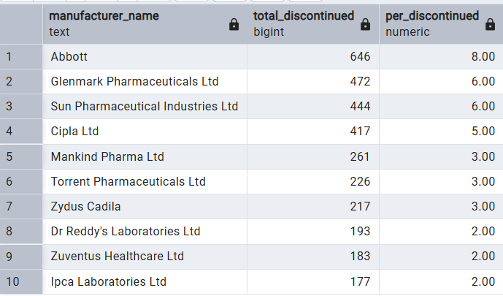

Q4. Substitute Mapping Potential Identify therapeutically similar medicines based on compositions for recommendation and alternative sourcing strategies.
Query:
SELECT
CASE
WHEN short_composition2 = 'Not Available' THEN short_composition1
ELSE short_composition1 || ' + ' || short_composition2
END AS composition_signature,
STRING_AGG(name, ', ') AS substitute_medicines,
COUNT(*) AS total_brands
FROM med
GROUP BY composition_signature
HAVING COUNT(*) > 1
ORDER BY total_brands DESC;

Result:
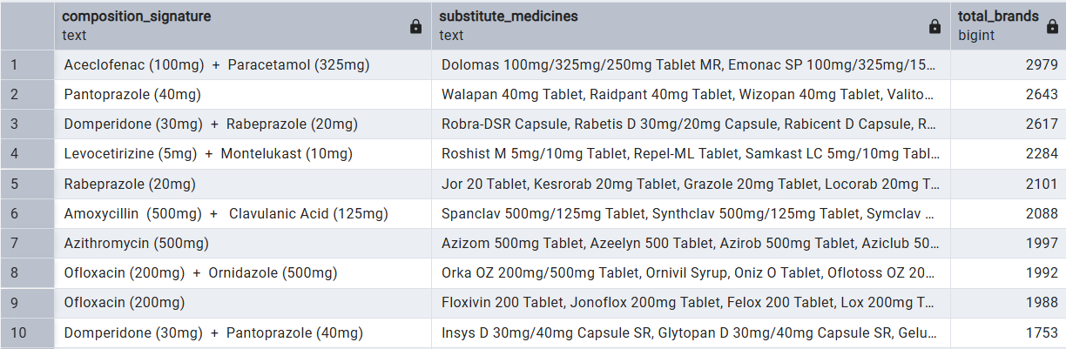

Q5. Examine commonly used pack sizes and price differences across pack variations to optimize procurement.
Query:
SELECT
pack_size_label,
COUNT(*) total_count,
ROUND(AVG(price) :: NUMERIC,2) avg_price,
MIN(price) min_price,
MAX(price) max_price
FROM med
GROUP BY pack_size_label
ORDER BY total_count DESC;

Result:
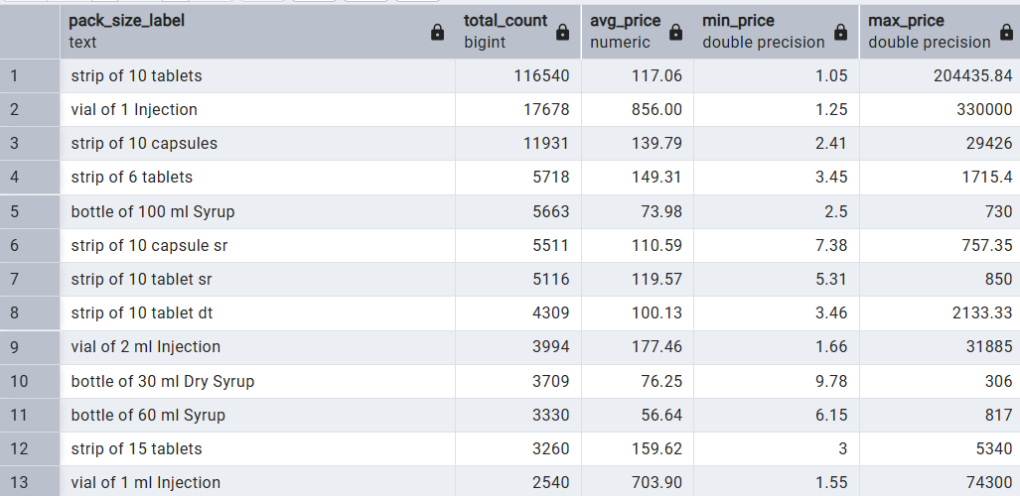

Q6. Shows whether certain pack sizes inflate cost unnecessarily.
Query:
SELECT
name,
short_composition1,
short_composition2,
pack_size_label,
price,
ROUND(
AVG(price) OVER(PARTITION BY short_composition1, short_composition2) :: NUMERIC ,2
) avg_price_for_sm_composition
FROM med
ORDER BY short_composition1, short_composition2, price;

Result:
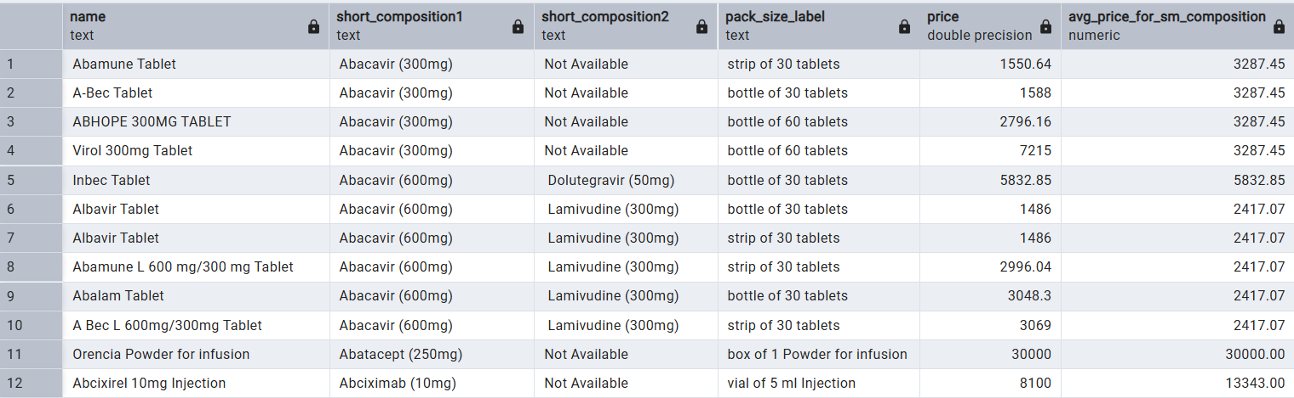

Q7. Compare average prices per manufacturer to understand competitive pricing positioning.
Query:
WITH manufacturer_stats AS(
SELECT
manufacturer_name,
medicine_type,
ROUND(AVG(price):: NUMERIC,2) avg_price
FROM med
GROUP BY manufacturer_name, medicine_type
)
SELECT
manufacturer_name,
medicine_type,
avg_price,
ROUND(AVG(avg_price) OVER() :: NUMERIC,2) overall_avg_price
FROM manufacturer_stats;

Result:
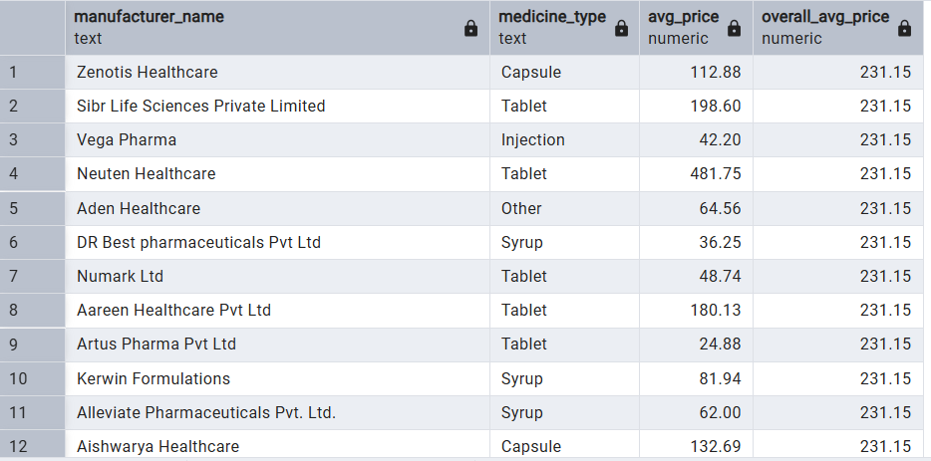

Q8. Evaluate dominance of medicine types (e.g., Tablets, Capsules etc) to understand market segmentation.
Query:
SELECT
medicine_type,
COUNT(*) total_count,
MIN(price) min_price,
MAX(price) max_price,
ROUND(AVG(price)::NUMERIC,2) avg_price
FROM med
GROUP BY medicine_type
ORDER BY total_count DESC;

Result:
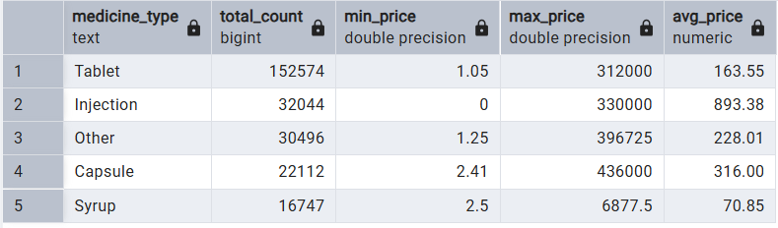

Power BI Dashboard:
- Schemas:

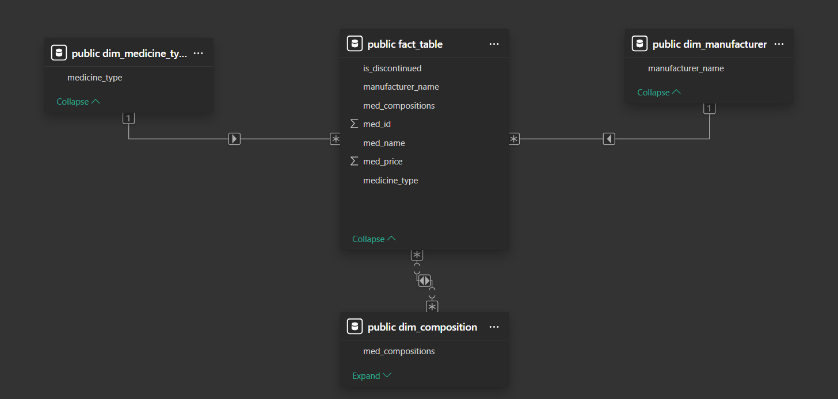

- Dashboard:

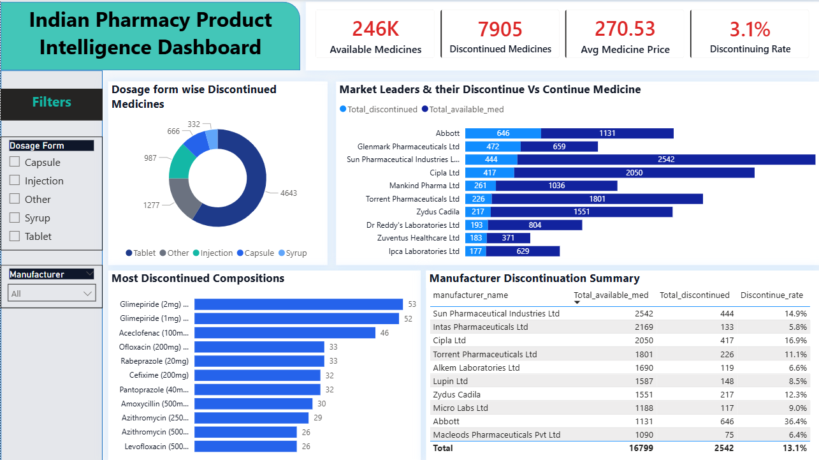

Market Insights:
Based on SQL analysis of 246K Indian medicine products:

1. Manufacturer Market Dominance
A small group of manufacturers controls the majority of listed medicines. Sun Pharmaceutical Industries Ltd and Cipla Ltd and few others lead the market in total product availability.
Business implication:
High supplier dependency procurement teams should avoid over-reliance on a few manufacturers to reduce supply-chain risk.
2. Discontinued Medicine Risk
Approximately 3.1% of medicines are discontinued. Certain manufacturers show higher discontinuation rates compared to the market average.
Business implication:
Pharmacies should monitor high risk manufacturers and reduce inventory holding of frequently discontinued products to avoid dead stock losses.
3. Dosage Form Trends
Tablets dominate the product landscape, followed by capsules and syrups. Injection forms represent a smaller but higher value segment.
Business implication:
Shelf-space allocation and procurement budgets should prioritize tablet-based medicines while maintaining selective stock of high cost injections.
4. Therapeutic Substitution Opportunities
Many compositions have multiple substitute brands, with some compositions showing 50+ alternative products.
Business implication:
Pharmacies can recommend lower cost substitute brands and negotiate better procurement contracts based on available alternatives.
5. Composition Discontinuation Hotspots
Certain drug compositions appear repeatedly in discontinued products.
Business implication:
These compositions indicate declining therapeutic demand or regulatory pressure pharmacies should gradually phase out stocking of these compositions.
6. Pricing Variation Across Manufacturers
Significant price differences exist among manufacturers for similar medicine types.
Business implication:
Procurement teams can optimize sourcing by selecting cost effective manufacturers without sacrificing therapeutic coverage.

Project Conclusion:
- This project successfully demonstrates how PostgreSQL analytics can transform raw medicine master data into actionable pharmacy market intelligence.
- By building a structured star schema and applying advanced SQL queries the analysis uncovered manufacturer dominance patterns, discontinued medicine risks, therapeutic substitution clusters and pricing variation across dosage forms.
- The final Power BI dashboard enables interactive exploration of these insights, supporting data-driven decisions in pharmacy procurement, inventory planning and alternative medicine recommendation strategies.

